Application settings

What Are Application Settings?
# Source: AI Source: Provided by: [Data Path: Persons Table -> ID Column: 1, Name_En Column: Motasem Essam] -> From: [Chatgpt (GPT‑5 Mini)] on [1/26/2026]
Application settings are configuration options that control how a specific application behaves.
- Unlike system settings, which affect the whole operating system, application settings only affect the program itself.
- They are used to customize behavior, appearance, and functionality of an app without changing the code.

Key Characteristics
# Source: AI Source: Provided by: [Data Path: Persons Table -> ID Column: 1, Name_En Column: Motasem Essam] -> From: [Chatgpt (GPT‑5 Mini)] on [1/26/2026]
- Program-specific – Each application has its own set of settings.
- Configurable – Developers or users can change them.
- Flexible – Can vary between environments (development, testing, production).
- Stored separately from code – Often in files (.env, config.json, settings.ini) or in databases.

Common Examples in Web Development
# Source: AI Source: Provided by: [Data Path: Persons Table -> ID Column: 1, Name_En Column: Motasem Essam] -> From: [Chatgpt (GPT‑5 Mini)] on [1/26/2026]
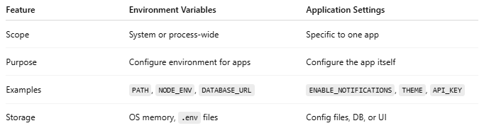
Type | Example | Description
Database | DB_HOST, DB_USER, DB_PASSWORD | Configures how the app connects to a database
API / Services | API_KEY, API_URL | Defines external services the app uses
Features | ENABLE_SIGNUP = true | Turns features on or off without changing code
Appearance / UI | THEME = "dark" | Customizes look & feel of the app
Environment | ENV = "development" | Determines app behavior for dev, test, prod

How They Are Managed
# Source: AI Source: Provided by: [Data Path: Persons Table -> ID Column: 1, Name_En Column: Motasem Essam] -> From: [Chatgpt (GPT‑5 Mini)] on [1/26/2026]
- Configuration Files
  - JSON: config.json
  - INI: settings.ini
  - YAML: config.yaml
  - Environment files: .env
- Application Dashboard / UI
  - Some apps allow changing settings via a settings page (like WordPress, VS Code, or Shopify).
- Database
  - Some dynamic apps store settings in the database for runtime flexibility.

Difference from Environment Variables
# Source: AI Source: Provided by: [Data Path: Persons Table -> ID Column: 1, Name_En Column: Motasem Essam] -> From: [Chatgpt (GPT‑5 Mini)] on [1/26/2026]
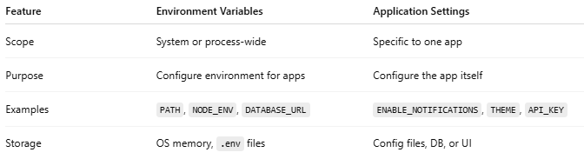
Feature | Environment Variables | Application Settings
Scope | System or process-wide | Specific to one app
Purpose | Configure environment for apps | Configure the app itself
Examples | PATH, NODE_ENV, DATABASE_URL | ENABLE_NOTIFICATIONS, THEME, API_KEY
Storage | OS memory, .env files | Config files, DB, or UI

Application settings Examples
# Source: AI Source: Provided by: [Data Path: Persons Table -> ID Column: 1, Name_En Column: Motasem Essam] -> From: [Chatgpt (GPT‑5 Mini)] on [1/26/2026]
Let’s look at practical examples of application settings, especially in web development. I’ll show realistic cases so you can see how they’re used.

1. Using a .env file (common in web apps)
# Source: AI Source: Provided by: [Data Path: Persons Table -> ID Column: 1, Name_En Column: Motasem Essam] -> From: [Chatgpt (GPT‑5 Mini)] on [1/26/2026]
.env file:
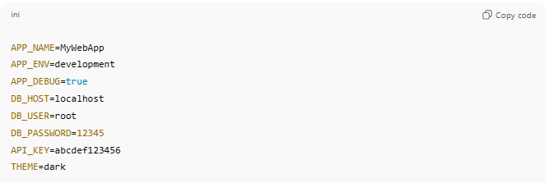
APP_NAME=MyWebApp
APP_ENV=development
APP_DEBUG=true
DB_HOST=localhost
DB_USER=root
DB_PASSWORD=12345
API_KEY=abcdef123456
THEME=dark
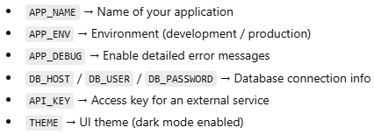
- APP_NAME → Name of your application
- APP_ENV → Environment (development / production)
- APP_DEBUG → Enable detailed error messages
- DB_HOST / DB_USER / DB_PASSWORD → Database connection info
- API_KEY → Access key for an external service
- THEME → UI theme (dark mode enabled)
In code (Node.js example):
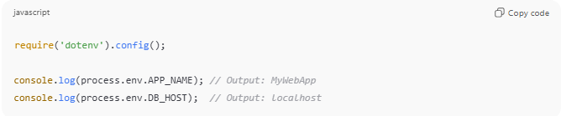
require('dotenv').config();

console.log(process.env.APP_NAME); // Output: MyWebApp
console.log(process.env.DB_HOST); // Output: localhost

2. Config File Example (JSON)
# Source: AI Source: Provided by: [Data Path: Persons Table -> ID Column: 1, Name_En Column: Motasem Essam] -> From: [Chatgpt (GPT‑5 Mini)] on [1/26/2026]
config.json:
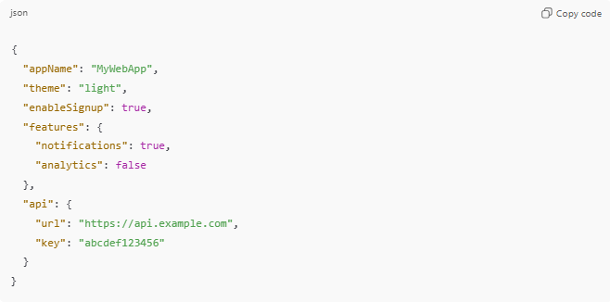
{
"appName": "MyWebApp",
"theme": "light",
"enableSignup": true,
"features": {
"notifications": true,
"analytics": false
},
"api": {
"url": "https://api.example.com",
"key": "abcdef123456"
}
}
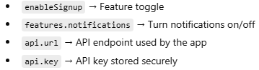
- enableSignup → Feature toggle
- features.notifications → Turn notifications on/off
- api.url → API endpoint used by the app
- api.key → API key stored securely
In code (JavaScript example):
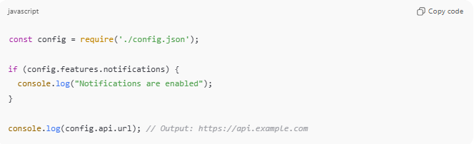
const config = require('./config.json');

if (config.features.notifications) {
console.log("Notifications are enabled");
}

console.log(config.api.url); // Output: https://api.example.com

3. Application Dashboard Settings Example
# Source: AI Source: Provided by: [Data Path: Persons Table -> ID Column: 1, Name_En Column: Motasem Essam] -> From: [Chatgpt (GPT‑5 Mini)] on [1/26/2026]
Imagine a web app like WordPress:
- Theme → Dark / Light
- Enable comments → True / False
- Default language → English / Spanish
- API integration → Paste API key for payment gateways or maps
These are all application settings that don’t require changing the code.

✅ Key takeaway:
# Source: AI Source: Provided by: [Data Path: Persons Table -> ID Column: 1, Name_En Column: Motasem Essam] -> From: [Chatgpt (GPT‑5 Mini)] on [1/26/2026]
Application settings are configurable options specific to the app, stored in files, environment variables, databases, or a UI dashboard. They allow the app to adapt to different environments, features, and user preferences without touching the main code.

💡 Analogy:
# Source: AI Source: Provided by: [Data Path: Persons Table -> ID Column: 1, Name_En Column: Motasem Essam] -> From: [Chatgpt (GPT‑5 Mini)] on [1/26/2026]
If your system is a house, and system settings are the main switches, application settings are the instructions for each room, like “heater on in the bedroom” or “music volume low in the living room.”

System Settings vs Application settings
# Source: AI Source: Provided by: [Data Path: Persons Table -> ID Column: 1, Name_En Column: Motasem Essam] -> From: [Chatgpt (GPT‑5 Mini)] on [1/26/2026]
Perfect! Let’s compare System Settings and Application Settings side by side so the difference is crystal clear.
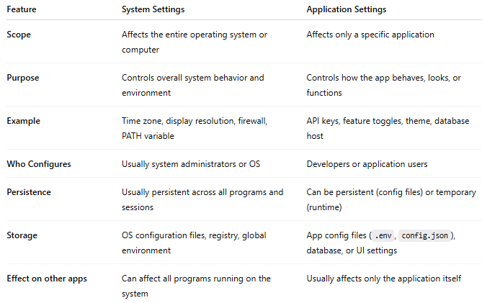
Feature | System Settings | Application Settings
Scope | Affects the entire operating system or computer | Affects only a specific application
Purpose | Controls overall system behavior and environment | Controls how the app behaves, looks, or functions
Example | Time zone, display resolution, firewall, PATH variable | API keys, feature toggles, theme, database host
Who Configures | Usually system administrators or OS | Developers or application users
Persistence | Usually persistent across all programs and sessions | Can be persistent (config files) or temporary (runtime)
Storage | OS configuration files, registry, global environment | App config files (.env, config.json), database, or UI settings
Effect on other apps | Can affect all programs running on the system | Usually affects only the application itself

Key Differences in Simple Terms
- System Settings = global control switches
  - Like the main electricity, network, or security settings in a house.
- Application Settings = app-specific rules
  - Like controlling the thermostat or light in a single room without changing the rest of the house.

💡 Tip for Web Development:
- Use System Settings for OS-level stuff (paths, time zone, security)
- Use Environment Variables for secret or environment-specific info
- Use Application Settings for app behavior, features, and user preferences

System Settings, Environment Variables, and Application Settings diagram
# Source: AI Source: Provided by: [Data Path: Persons Table -> ID Column: 1, Name_En Column: Motasem Essam] -> From: [Chatgpt (GPT‑5 Mini)] on [1/26/2026]
